ARCOT HALL GOLF CLUB

4 PERSON TEAM EVENT
BEST 2 SCORES FROM 4 ON EACH HOLE
STABLEFORD SCORING

SUNDAY 25th June 2023
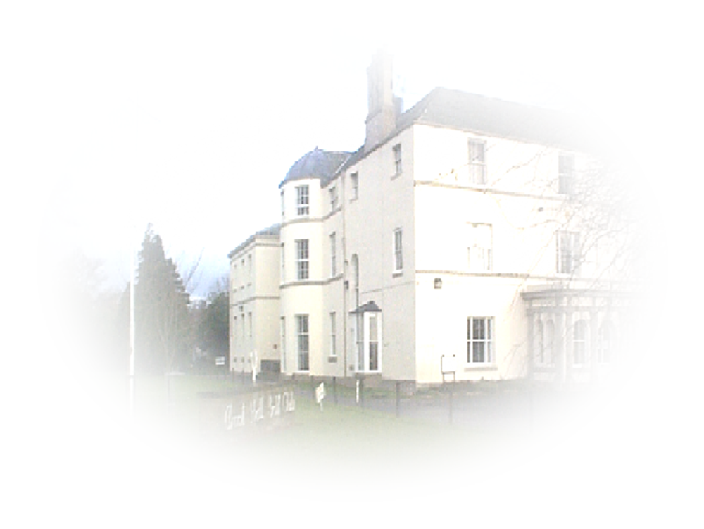
ENTRY FEE £60.00 PER TEAM of 4

Voucher Prizes for top 4 Teams

Maximum Playing Handicap Men 24, Ladies 30

Prize winners will be required to produce Handicap Certificates

ENTRIES WITH ENTRY FEE SHOULD BE SENT TO:-
The Business Administrator
Arcot Hall Golf Club
Dudley
Cramlington
Northumberland
NE23 7QP
Telephone number 0191 2362794

Please specify preferred tee time with entry.

