ARCOT HALL GOLF CLUB

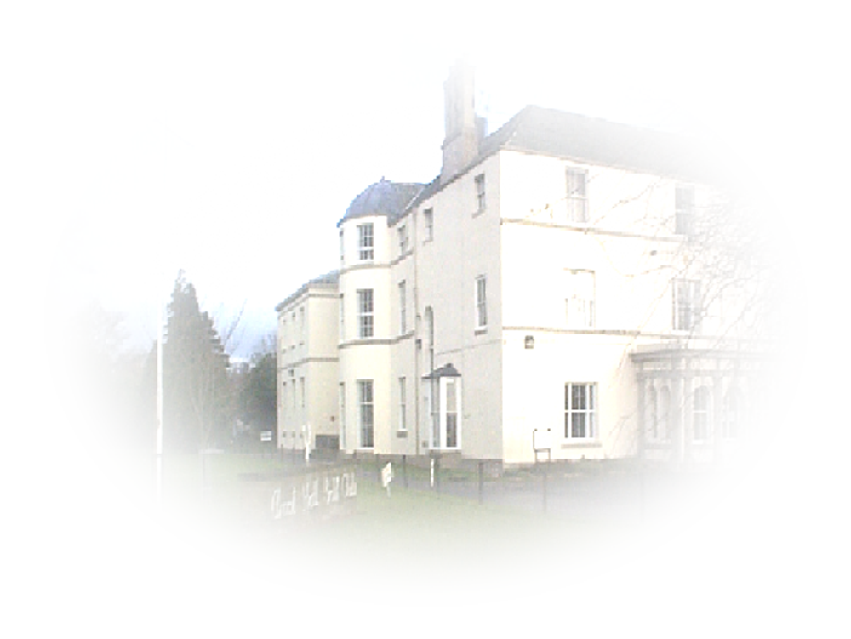
SENIOR MEN’S SUMMER OPEN
4 BALL BETTER BALL
STABLEFORD

MONDAY 31ST JULY 2023

ENTRY FEE £25.00 PER PAIR
(to include 2’s club)

Prizes for the Best 5 scores will be given
Minimum Age 60 Years
90% of Club Handicap (Maximum Handicap 28)
Handicap Certificates may be required

Applications must be on an official entry form or in writing to include name, handicaps of both players, home clubs, contact address, phone number and preferred starting time together with an e-mail address or a stamped addressed envelope for reply.

ENTRIES WITH ENTRY FEE SHOULD BE SENT TO:-
The Business Administrator
Arcot Hall Golf Club
Dudley
Cramlington
Northumberland
NE23 7QP
Telephone number 0191 2362794

