Friday 30/9/22

At the beginning of the month the Graden work was carried out on the greens, the Graden machine worked down to a depth of 25 mm, removing organic matter and other materials to that depth and injecting kiln dried sand. The whole process uses around 18 ton over the 18 greens that the work was carried out on, the work was not done on holes 6 & 8 as these greens are to be drained over the winter.

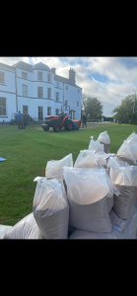

Following the Graden work we applied an organic fertiliser on the greens to aid recovery. Following this we seen a break in the weather with substantial rainfall over the next few days, unfortunately due to this rainfall the greens were unable to be cut, once the rain cleared and the greens were dry enough they were then cut and then we seen good recovery across the greens.

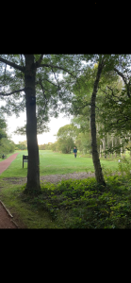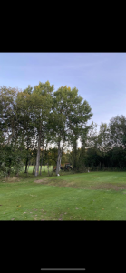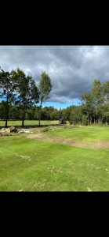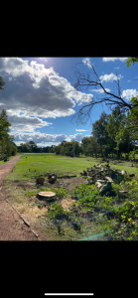
Other planned work for the winter is the renovation of the the 3rd yellow tee and the 4th medal tee, with this in mind we moved on to tree removal in these areas. The removal of the trees is to allow better airflow and light, also the roots from the large poplar trees around the 4th tee were starting to migrate into the tee and are becoming dangerous to golfer, plus they take a lot of the moisture from the tee. The work around the 3rd is still ongoing and we hope to finish this in the next couple of weeks. This pictures below show the work that has already been carried out to the right of the 3rd tees.

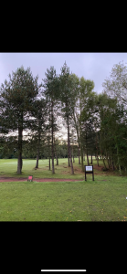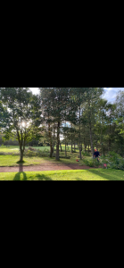

Earlier this week members may have noticed small holes on the greens, these are caused in the process of over seeding. The over seeding unit punches small holes in the surface where the grass seed then falls into these holes, once this process in complete the greens are top dressed with a light dressing of sand to create a seed bed for the seed to then germinate. The seed used for this is a Bent grass, which is a very fine seed which germinates into a fine grass which helps to produce a good putting surface.

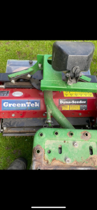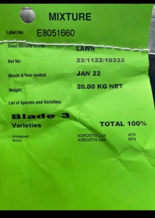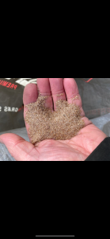

Going forward we are looking to apply a liquid mix of feed to the greens over the next week. Drainage work on the 6th and the 8th greens will commence on the 10th of October, as will the renovation work that is being carried out on the 9th hole.

