Tuesday 28/6/22

Approaching the halfway point of the year we have found we’ve had one of the driest first 6 months to a calendar year for a very long time, certainly the one driest in the time we have kept rainfall records at Arcot, which began in the early 2000’s. We’ve only had 226mm’s of rainfall to date, in comparison to this time last year which was 480mm’s. Couple this with a dry and hot spell in June and the problems that we’ve encountered with the irrigation system over the last couple of weeks, it can be seen that the greens and tee grounds are a lot drier than we would like. The issues we have had to deal with have been with the valves which serve the individual greens and tees, this on its own can normally be fixed and up and running with minimal impact to the water supply to the greens and tees. However getting spare parts at the moment has been troublesome and we have been unlucky that breakdowns have came in quick succession. For instance when the valve at the back of the 6th green needed to be replaced it had a slight leak which we could manage, however before we could get the new valve in the old one burst so we needed to shut the system down for a couple of days before we could repair the valve and get it working again. The same day the 6th was fixed the valve at the back of the 11th green burst meaning that the system was once again off leading to around 5 days without water to all greens and tees. The system is back up to almost full strength now with a couple of minor issues we can work with, so we should start to see and improvement in these areas going forward.

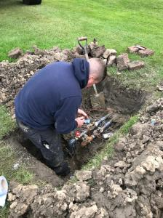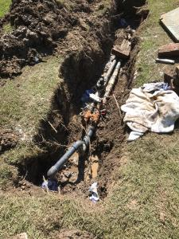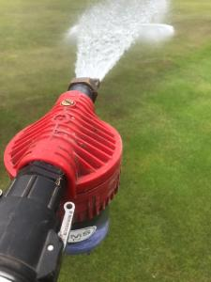

Above are a couple of photos of the 6th and 11th valves being repaired, also the 3rd photo is shows the manual wetting agent applicator which we use with the hosepipes to hand water the greens in extremely dry conditions. This spot treatment has been done over the last couple of days and will continue during this dry spell.

The planned work on the greens and the rest of the course has still been going on, with the greens being verti-cut twice and also one application of top dressing. We also continue with our spraying programme on the greens every 3/4 weeks.

We’re around halfway through the spraying of weed killer around the golf course, you can see on some of the holes the weeds are starting to die back, this work should be completed over the next couple of weeks. Elsewhere on the golf course the grass growth has slowed down with the lack of rainfall, the areas such as greens surrounds, fairways and semi-rough are still cut however the frequency can be reduced. With the growth on the main areas of the course slowing we’ve been able to get into some of the areas that were cut out with the deck over the winter months with a 2nd and in some cases a 3rd cut. Areas such as the left hand side of the 5th and parts of the 16th that were cut out by the deck have improved so much they are now being cut using the semi-rough cutter. The picture below shows this work on the 10th being carried out.

