Friday 25/3/22

In contrast to the last update the weather has been very kind to us over the last 2 weeks. The work that we weren’t sure of getting finished on the 16th is now almost complete. The removal of all the trees and shrubs has been done and there is just a few remaining stumps to be ground down before we can get the large cutting deck in to finish off the job. As you can see from the photos below it has really opened up that side of the hole and we will have a few more yards of semi rough to maintain down that side before too long.

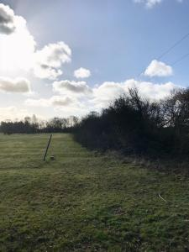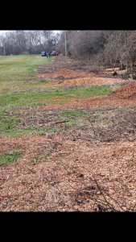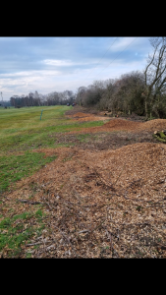

On the 15th of march we had the contractors in to spread the fertiliser on the fairways and surrounds, this is something that has been done for the last couple of years and we have seen a marked improvement in these areas in terms of growth a playability. We also fed the greens with a granular fertiliser designed to promote early growth in the spring and to help green up the surface which in turn allows the grass plant to take in more sunlight during periods of cooler weather.

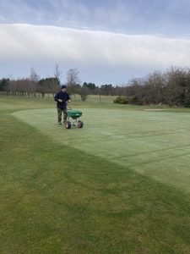

With the the break in the weather we have been able to get on with work on the greens that would not normally be done at this time of year. Earlier this week the greens were given a heavy dressing of sand, which was brushed in then later we were able to get the turf iron across them to leave the surface looking very good and from the feedback from the members running very nice. This has been followed up by a few cuts of the greens, once the morning dew has dried of as not disrupt the playing surface by pulling up the sand that had been spread. Also this week we have been able to get out with the mowers around the course and cut the tees, aprons/surrounds and the fairways, its fair to say that the golf course is looking in very good condition leading up to the start of the season and the feedback from the members who’ve been put playing has supported this. Finally tidying up of fallen branches and trees around course has continued and the topping off of the hedge at the first tee has been done.

