Friday 22/7/22

We’re very pleased to report that the greens are well on road to recovery. We applied a granular fertiliser rich in Nitrogen which has encouraged a good steady boost in growth enabling good recovery from the dry patchy areas we previously had. The water system has been running at full capacity for two weeks with the greens being the main focal point of the irrigation, meaning the tee areas hadn’t had as much water as previous weeks however once the greens were showing good recovery we were able to then turn down the water to the greens slightly and apply more to the tee areas. Regarding the tee areas, in the coming days/weeks the old sprinklers will be replaced with new ones which should help to improve the irrigation of the tees.

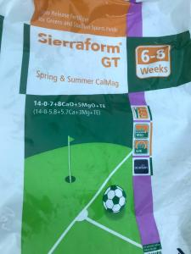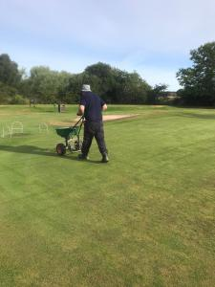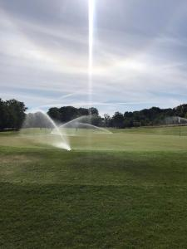

Once the fertiliser had been watered in fully and started to take affect we then moved on to the aeration of the greens. As previously mentioned this isn’t a job that’s just done in the winter months, it needs to be done all year round, at this time of year it is far less disruptive to the putting surface than in the winter months. As you can see in the picture of the verti-drain the tines are thin ‘6mm’ and with the greens being firm we managed to tine to a depth of around 3 inches. The greens recover from this process quickly so if you only play golf late in the week you may not even have noticed that work had been done.

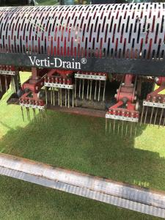

As mentioned above the recovery on the greens following the fertiliser application has been really good, with the sward improving/thickening we were able to continue with the verti-cutting. Over the winter the golf club purchased some new verti-cutting units to fit on the John Deere greens mower, this week was the first time they were used on the greens. The units were set up to cut 2mm below the surface. On the morning the greens were first brushed with the multi brush to help remove the morning dew then verti-cut and were then cut using the greens mower.

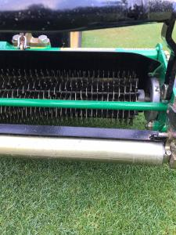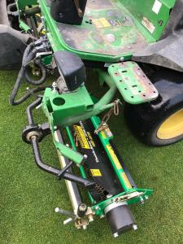
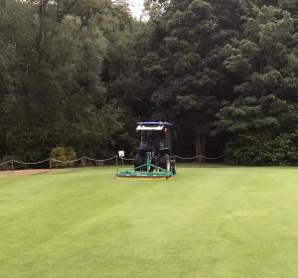

On Friday morning ‘22nd’ the greens were sprayed with a product called Aquaduct, this is a rapid recovery soil surfactant/wetting agent which helps in the recovery of dry areas in turf. Aquaduct reduces the water repellency in the soil structure which can be caused by a prolonged dry spell. Meaning that once applied the rootzone can then regain the moisture levels required for good growth. The progress of this will be monitored going forward.

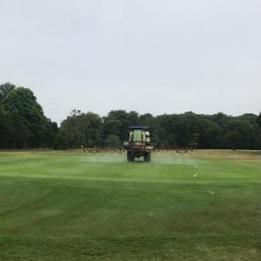

Some may have noticed that the flag pole from the front of the club house has been moved, its being treated to some much needed TLC. The old paint is in the process of being removed and will then be repainted and returned once complete.

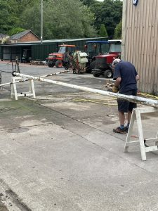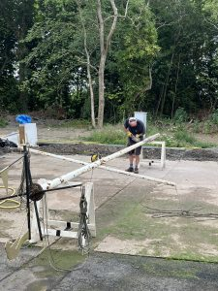

It has been noted recently that the bunkers are in need of sand replenishment, we have took delivery of some new Mansfield sand, the same that’s in the bunkers to the right hand side of the 6th green. We’re looking to start this work next week. Also as stated above the replacement of old sprinklers will also continue in the coming weeks.

