Thursday 20/10/22

Work on the 9th hole has been progressing well over the last couple of weeks, below is a few photos and a little bit of background information as to what has been going on.

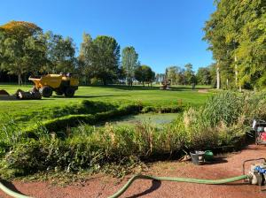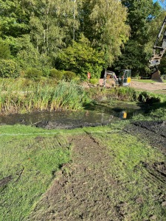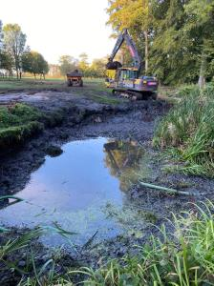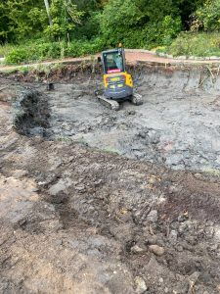

Work began with the draining of the pond, once the water level was low enough work began to dig out the pond removing all the old vegetation and slurry from the bottom.

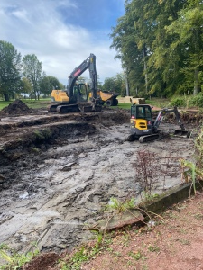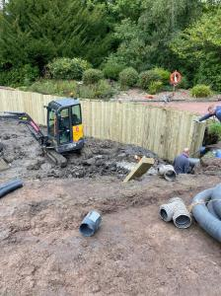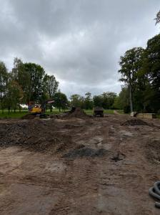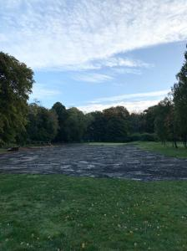

Once the pond was cleared and the depth for the new pond was reached work then progressed to the installation of the timber sleepers which would become the perimeter of the pond. The scraping off of the old soil and shale from the fairway area began, also removing the bunker from the middle of the fairway. Once this was all scraped off new soil was then brought in to replace the old material, 200 ton of soil in total was used for this.

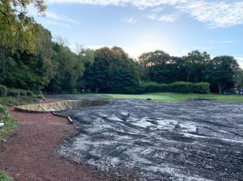

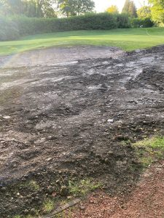

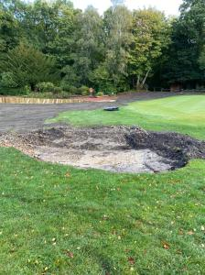

The left hand green side bunker has also been filled in and work on a new smaller pot bunker to the right hand side of the green has began.

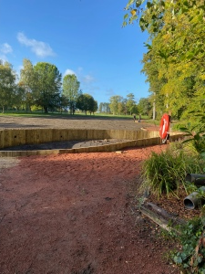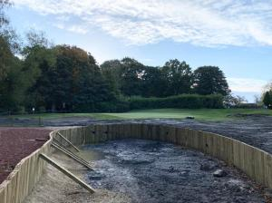

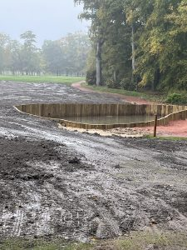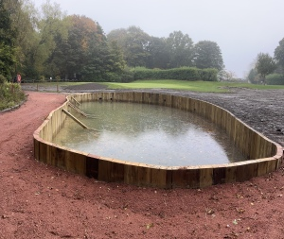

The work on the pond itself is now complete with the outlet and inlets for various drains tapped in through the The sleepers.

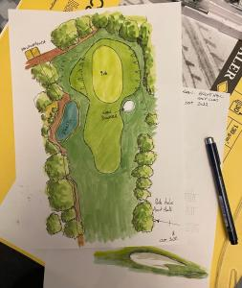

Work will continue on the 9th over the coming weeks with more soil to be taken in and the finishing touches such as turfing and the completion of the new bunker. The final picture is an example of what we are looking to achieve. This work will be carried out along side the greens staffs winter work programme.

