Friday 18/11/22

Work on the 9th green has now been completed, as previous communication the work started from the green area working back towards the tee. The area was divided into 3 sections, 600 sq metres were ordered for each section totalling in 1800 sq metres of turf.
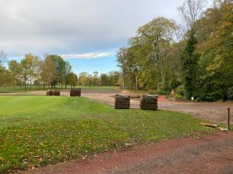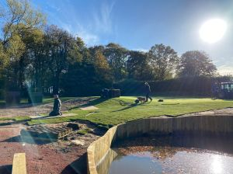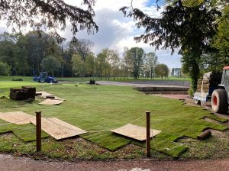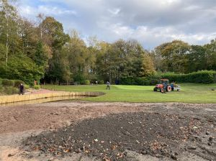
Once the turf was laid in each section the next section was then prepared. A covering of sand was applied to the whole area and raked level ready for turf.
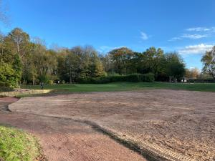

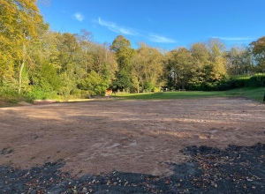
The final roll of turf was laid on the 9th on Tuesday, thanks to Paul and Steve for helping to lay the turf, the aches and pains wear off in time. The last thing to be done in the area is the completion of the new bunker to the right hand side of the hole.
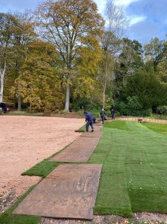
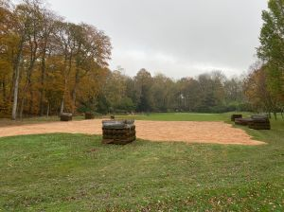

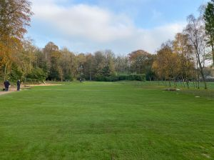
While the work was being done on the 9th other jobs have also been done, the greens were verti-drained to a depth of 8 inches using half inch tines. Once this was completed we applied a winter fertiliser to the greens. Work has also started on the 3rd tee with the removal of the turf.
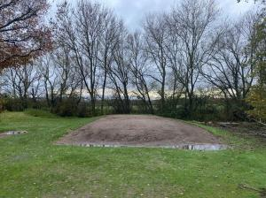

Unfortunately since the turf was removed on Wednesday we’ve been unable to access the area due to the heavy rain that has fell over Wednesday evening through to Friday morning. Over 3 days we have had a total of 67mm of rainfall, which is around the monthly average for November so as can be imagined the area is now saturated. Over the next couple of weeks work will continue on the 3rd tee and we will continue to work through the winter work program.

