Friday 13/5/22

We’re now in full flow with the mowing around the golf course, with the Fairways, surrounds and the parts of semi rough where the fertiliser was applied in march growing particularly hard, creating very good definition between the playing surfaces. This does mean that the machines are out more often cutting these areas to keep up the surfaces looking good and playing well. The 3 pictures below show the definition between the playing surfaces, from left to right we have the Fairway, First cut of semi rough and finally the rough, as you can see the ball gradually disappears into the longer grasses meaning it really does pay to hit the fairways at this time of year.

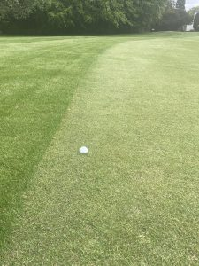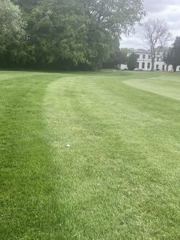
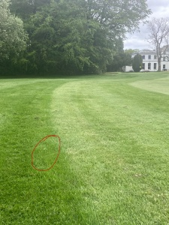

A granular fertiliser 8-0-6 ‘N-P-K’ has been applied to the Tee areas helping with the the growth of the grass. Below are a couple of pictures the first is the product that was applied to the tees and the second is a brief explanation of what the N-P-K numbers on the product mean and how they help the growth of the grass plant. This product also has added nutrients such as Iron (Fe) and Magnesium (Mg) which help the plant in the green up process to allow the plant to take in more heat from the sun to help yield a more dense sward.

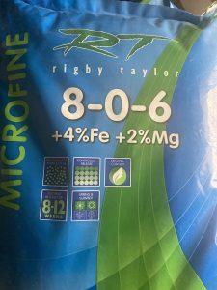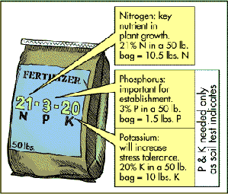

Greens

Areation work was carried out at the beginning of April. The greens were tined with 1/4 inch tines to a depth of 5 inches, we were able to get this depth as the greens were still relatively soft coming into spring. The summer liquid feed programme started, this consists of liquid iron, Attain, which is a organic liquid feed and finally Revolution, which is a wetting agent which helps the plant take in water through the root system. From the next application Primo Max will be added to the mixture which helps to regulate the growth of the grass to allow for a better putting surface between cuts. This process will be repeated every 4 weeks throughout the summer through to September. Verti cutting has also been carried out a couple of times to help reduce the levels of organic matter below the grass surface, this will be continued every 10-14 days.

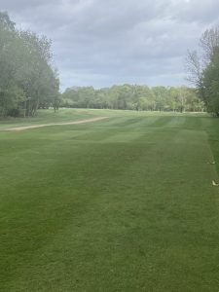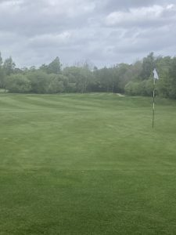

The photo on the left shows the 5th hole, showing the tee area and the positive affects of the fertiliser in the foreground. The photo on the right shows the 4th green where the drain lines are recovering very well.

Going forward we are looking to continue with the ongoing spraying, verti cutting and aeration programmes on the greens. The aeration work needs to be carried out around 4-6 weeks through out the summer months to help relieve soil compaction due to more maintenance and play, however the depth of this will reduce to between 2-3 inches due to the greens becoming firmer in the drier months. Finally we will be looking to apply 1 or 2 light dressings of sand to the greens to help maintain the putting surface.

