Friday 9/12/22

Over the last couple of weeks work has began on the drainage of the 8th green. This began by taking a main drain line across the front of the green, we then removed the turf and dig out a trench so we could run the drains through the green to this point and pipe across to a main carrying drain. The main drain was located in a rig towards the lefthand side of the green. This is a drain we inserted a few years ago to drain the green side bunker.

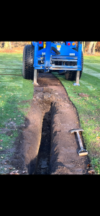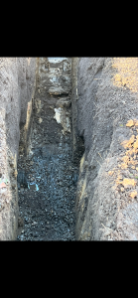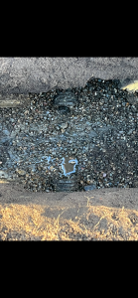

We then measured across the green marking a distance of 2.5 metres between each drain line. Once this was marked out the drain lines were cut using the turf cutter and the turf was removed from the green.

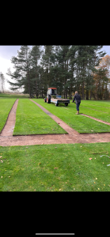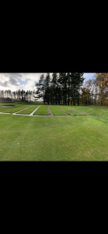

Once all the turf was removed we were then able to get on with the trenching through the green. We firstly removed the top layer of soil from the trench, we will use this soil on the damaged area on the corner of the 8th which was used a haulage root when the work was carried out on the 9th hole. Once this was removed we were then into the clay layer which was taken away and tipped in the woods. Depending how wet the clay is it can take 2/3 runs to get out the required amount of clay. Each trench is taken down to a total depth of 24-27 inches which enables us to insert a 4 inch pipe and at least 8 inches of gravel to help pull water through the surface. Once the gravel has been inserted we then top off with 10 inches of rootzone. To date we have completed 3 of the 6 drain lines on the 8th green.

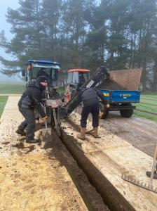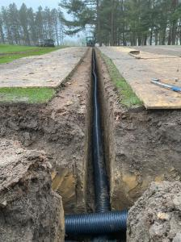

Work on the green stopped last Thursday as we needed to spray the main greens which a fungicide as wet/damp conditions had aided an outbreak of disease across the greens. The spraying was carried out on Friday and has been a success with the disease being suppressed. Unfortunately last weekend and the start of this week seen enough rainfall for the 8th green to become to wet to continue. Once the green dries out a little we will be back on to finish the remaining work. Work this week has moved on to the removal of trees from around the 15th green. This is a continuation of the work that was carried out last winter to allow better airflow throughout the hole. There is still more trees to come out along the left hand side but as you can see from the photos the trees removed around the back of the green have already made a noticeable difference.
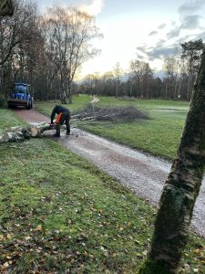

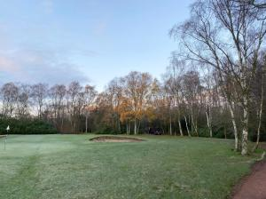

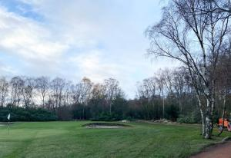

Going forward we will be looking to get on with the drainage work on the 8th green once ground conditions allow, until then work will continue on the removal of trees.

