Monday 7/3/22

The weather hasn’t been the kindest to us over the last couple of weeks with the end of February and the beginning of March being particularly wet, 72mm of rainfall in just over 2 weeks. This however hasn’t stopped the lads getting on with their work on the course. Clearing of trees and shrubs has continued on the course with work starting on the right hand side of the 16th hole.

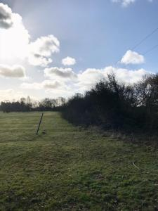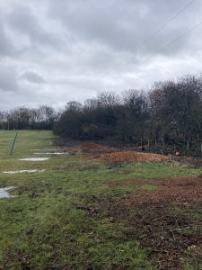
As you can see from the images above a fair amount of work has been carried out already, however with the poor ground conditions due to the rainfall the lads have had to leave this area for now and work on other projects, work will continue once access is better. This work will run all the way up the side of the hole so may run into the winter next year.
All of the bunkers around the course have had the edges trimmed around using the new trimming attachment for the pole saw. This new piece of equipment has help to speed up this process somewhat, previously it could take up to two weeks using an edging iron and clippers however now the work can be carried out easily within a week. In addition to this bunker work there have been some steps inserted into the green side bunkers on the right of the 6th hole. These have been put in to make it easier for golfers to enter and exit the bunkers at these points.
