ARCOT HALL GOLF CLUB

MEN’S 4 BALL BETTER BALL
STABLEFORD

SUNDAY 21st MAY 2023
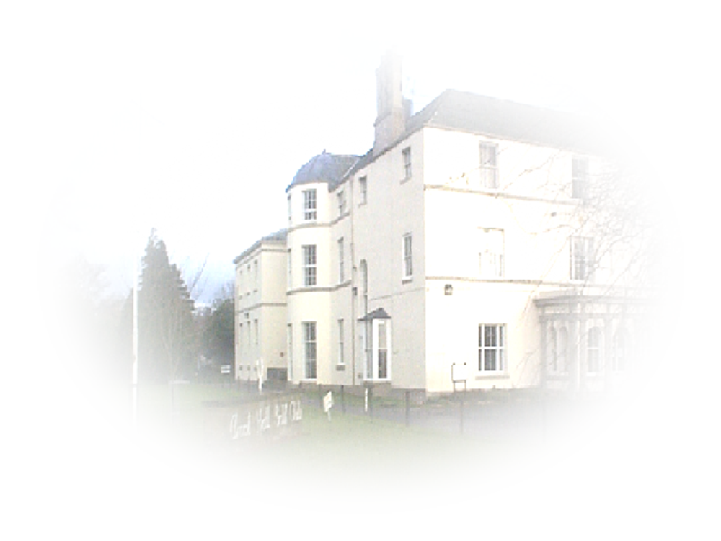
ENTRY FEE £30.00 PER PAIR

Voucher Prizes for top 4 Teams

Maximum Playing Handicap 24

Prize winners will be required to produce Handicap Certificates

ENTRIES WITH ENTRY FEE SHOULD BE SENT TO:-
The Business Administrator
Arcot Hall Golf Club
Dudley
Cramlington
Northumberland
NE23 7QP
Telephone number 0191 2362794

Please specify preferred tee time with entry.

