ARCOT HALL GOLF CLUB

LADIES OPEN
MONDAY 18th SEPTEMBER 2023

TEXAS SCRAMBLE
4 PERSON TEAM

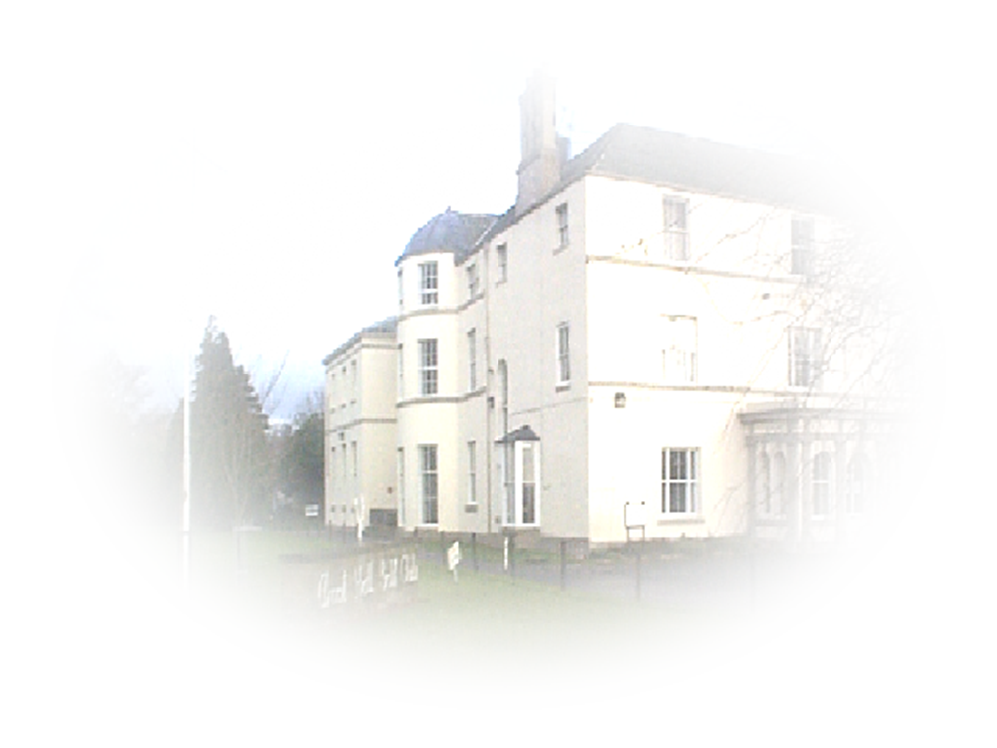
ENTRY FEE £40.00 PER TEAM OF 4

(no refund for cancellation)

PRIZES FOR THE FIRST 3 TEAMS

Maximum Individual Handicap 54

MEALS SERVED ALL DAY

ENTRIES WITH ENTRY FEE SHOULD BE SENT TO:-
Ms Susan Taylor
Treasurer – Ladies Section
Arcot Hall Golf Club
Dudley
Cramlington
Northumberland
NE23 7QP

Cheques payable to:
Arcot Hall Golf Club Ladies Section
(Please send s.a.e. for notification of starting time)

