ARCOT HALL GOLF CLUB

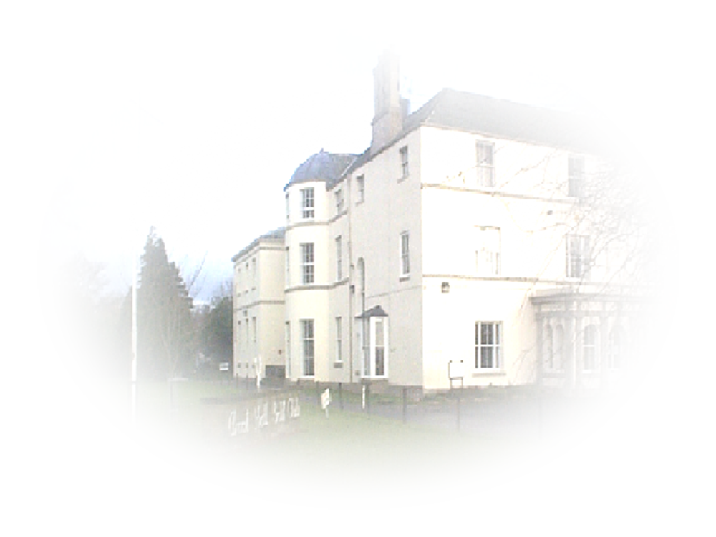

4 PERSON TEXAS SCRAMBLE
STROKEPLAY

SUNDAY 17th SEPTEMBER 2023

ENTRY FEE £60.00 PER TEAM

Voucher prizes for top 4 teams

Maximum Playing Handicap Men 24, Ladies 30

Prize winners will be required to produce Handicap Certificates

ENTRIES WITH ENTRY FEE SHOULD BE SENT TO:-
Business Administration
Arcot Hall Golf Club
Dudley
Cramlington
Northumberland
NE23 7QP
Telephone number 0191 2362794

Please specify preferred tee time with entry.

