Arcot Hall Golf Club
Presents
An Evening with
Paddy Kenny
Saturday 28th May 2022, 7pm for 730pm
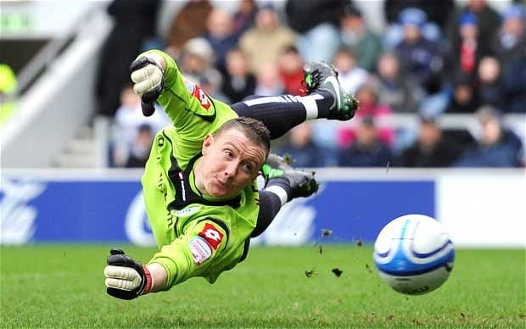
Q & A, Compare, Pie and Pea Supper & Raffle
Tickets £20.00 each – Available from the bar now
Stories of Warnock, Eyebrows, Muscat, Builders, the Drugs Ban and more
All proceeds to the Captain’s Charity
